  

TIJUANA INSTITUTE OF TECHNOLOGY

## ACADEMIC

DEPARTMENT SYSTEMS AND COMPUTING DEPARTMENT COMPUTER SYSTEMS ENGINEERING

SEMESTER FEBRUARY- JULY 2022

## SUBJECT

BDD-1703SC9C Data Mining

Activity

Practice #2

# Professor

MC JOSE CHRISTIAN ROMERO HERNANDEZ

# Student

17212327 -Aldarete Delgado Angel Esteban 17210659 - Villegas Carmona Damaris

Tijuana, BC March 08, 2022

### Function 1.- The rnorm(1) function

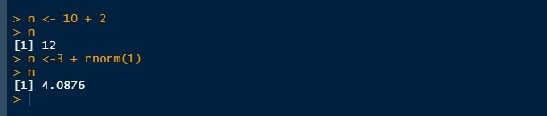generates random data samples from a normal distribution with mean 0 and variance 1.

### Function 2.- ls function

It is simply a list of objects in memory : Only their names are displayed

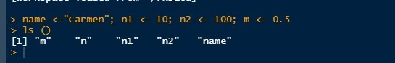.

### Function 3.- Function ls.str()

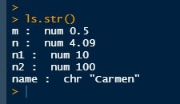shows some details of the objects in memory

### Function 4.- Function seq

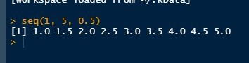can generate sequences of real numbers:

### Function 5.- Function rep

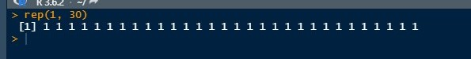creates a vector with identical elements:

### Function 6.- Function sequence

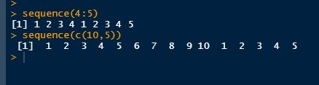creates a series of sequences of integers where each sequence ´ ends in the number (or numbers) specified as argument (s)

### Function 7.- Function gl

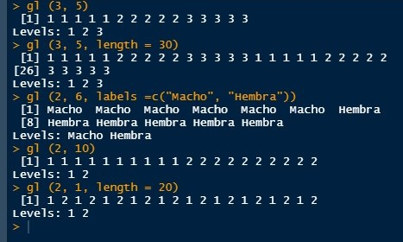e the form ´ gl(k, n) where k is the number of levels (or classes), and n is the number of replicas in each level.

### Function 8.- Function expand.grid()

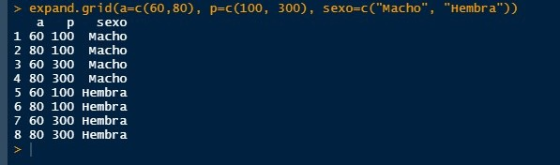creates a data frame with all the combinations of vectors or factors provided as arguments:

### Function 9.- Function levels

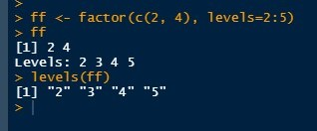extracts the possible levels of a factor:

### Function 10.- Function ts

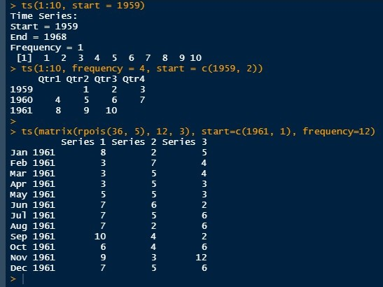The function ts creates an object of class "ts" (time series) from a vector (single time series) or a matrix (multivariate series).

### Function 11.- Function expression

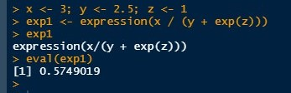Evaluates an expression

### Function 12.- Function rbind() and cbind()

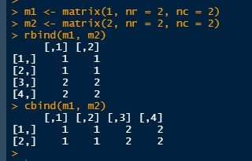bind matrices with respect to their rows or columns respectively:

### Function 13.- Function diag

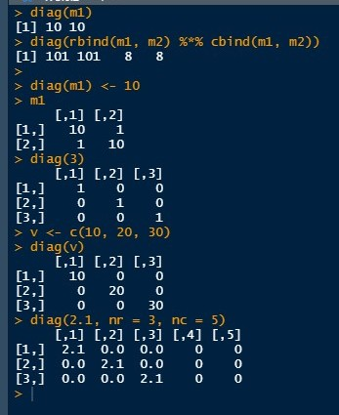can be used to extract or modify the diagonal of a matrix or to build a diagonal matrix:

### Function 14.- iris table

**Function 15.- plot function (iris) Iris**

graph

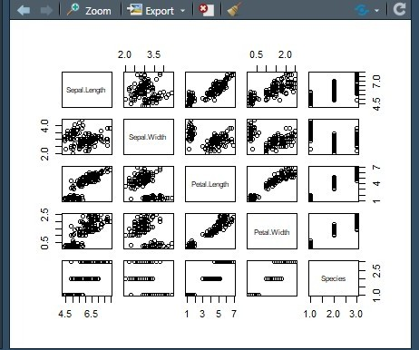

### Function 16.- nrow function (iris)

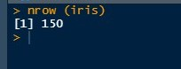Show only a number of rows

### Function 17.- colnames function (iris)

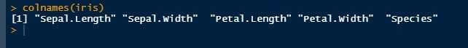Show the names of the rows

### Function 18.- Function ncol(iris)

Shows the number of columns

### Function 19.- Function summary(iris)

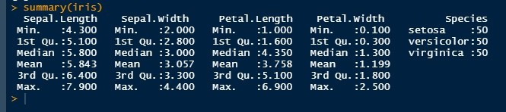Statistical summary of the columns

### Function 20.- Function Log

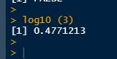The function log calculates a logarithm of a given numerical value :

**References**

Paradis, E. (nd). *R for Beginners*. Retrieved March 06, 2022, from <https://cran.r-project.org/doc/contrib/rdebuts_es.pdf>